SUSE JENKINS INTEGRATION
Suse Linux Instance
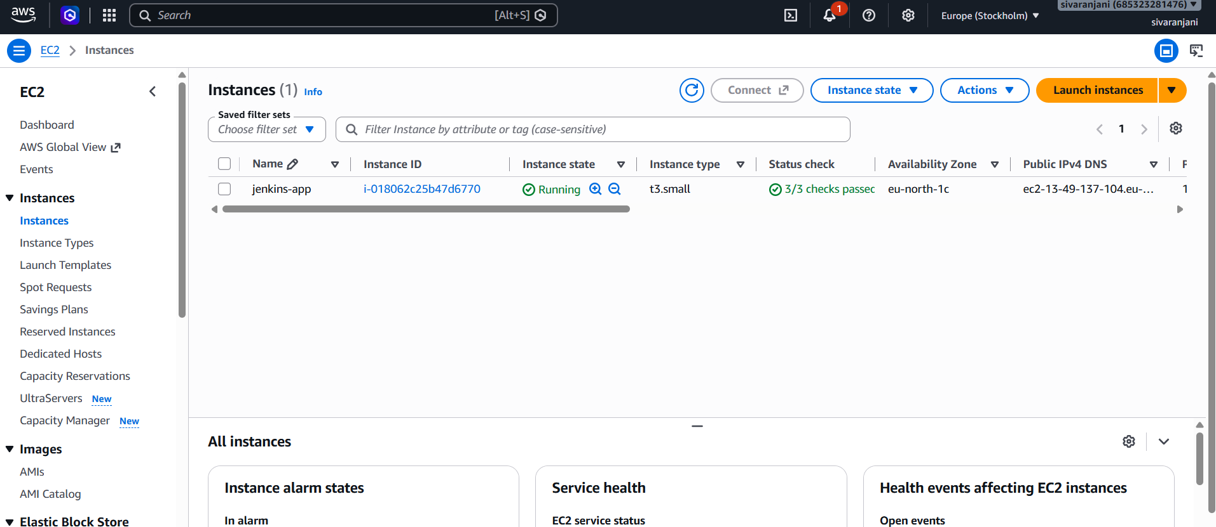

Installed Java runtime
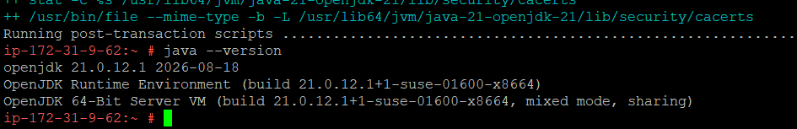
Jenkins is enabled and started
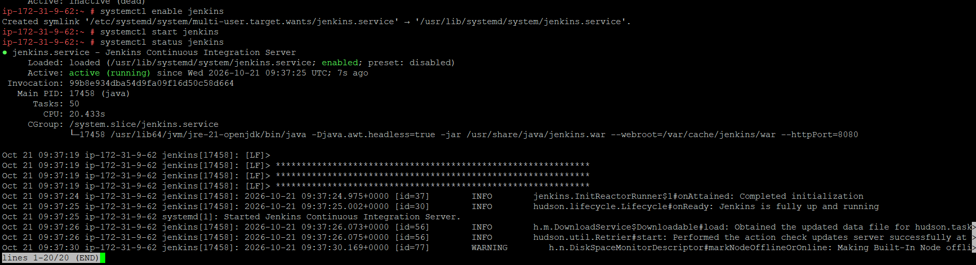
ps -ef | grep Jenkins -> process is running

Jenkins installed successfully in port 8080
